Needs Organics

Products Details:
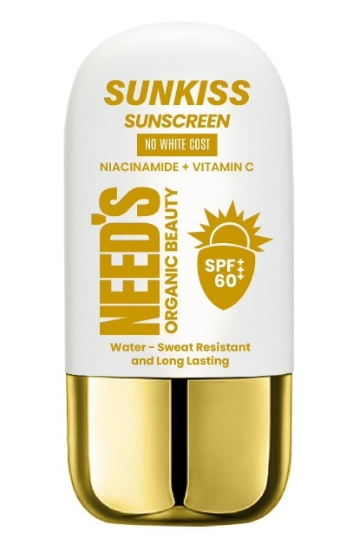
Need's SunKiss Sunscreen 50ml
P Price 3390 | Discount Price 2990
👉🏻Water-Resistant & Long-Lasting
(Designed to withstand sweat and water,ensuring dependable sun protection during outdoor activities.)
👉🏻Ultimate Sun Protection
(Formulated with SPF 60+++ and advanced UV filters,including Octocrylene and Butyl Methoxydibenzoylmethane,for broad-spectrum protection against UVA and UVB rays.)

👉🏻Lightweight,Non-Greasy Formula
(Silky,quick-absorbing texture leaves no white cast,offering a matte finish perfect for men's and women's active lifestyles)
👉🏻Brightening & Skin-Strengthening
(Infused with Niacinamide and 3-O-Ethyl Ascorbic Acid to improve skin tone,reduce dark spots, and enhance skin resilience.)
👉🏻Nourishing Plant Extracts
(Enriched with Dandelion Leaf Extract,Stephania Tetrandra Extract,and saururus chinensis Extract to soothe and calm skin while delivering antioxidant benefits.

KEY INGREDIENTS
⭐3-O-Ethyl Ascotbic Acid ⭐Phenylbenzimdazole Sulfonic Acid
⭐Niacinamide ⭐Zinc Oxide
⭐Ethylhexyl Salicylate ⭐Sodium Hyaluronate
⭐Butylene Glycol ⭐Sorbitan Isostearate
⭐Stephania Tetrandra Extract ⭐Aminomethyl Propanol
⭐1-2-Haxanediol
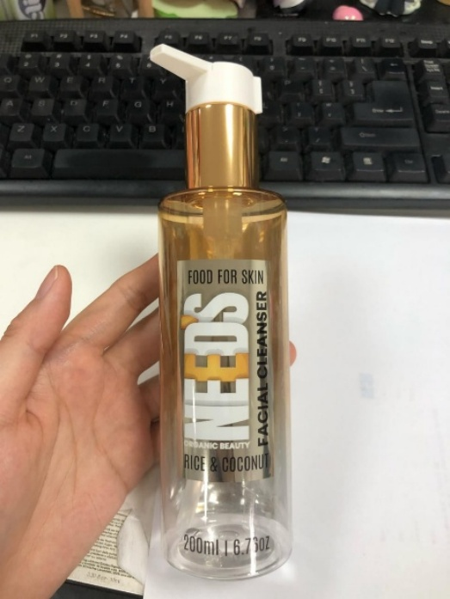
Need's Rice And Coconut Facial Cleanser 200ml
Price 3490 | Discount Price 2990
👉🏻Dual Whitening Technology
( Powered by Alpha-Arbutin and Glutathione,this cleanser effectively brightens the skin and reduces the appearance of dark spots and pigmentation.)
👉🏻Hydrating & Soothing Formula
(Deeply hydrate and calm the skin,leaving it soft and balanced)

👉🏻Vitamin-Infused Radiance
(Enhanced Brightening,anti-inflammatory properties,and improved skin texture)
👉🏻Antioxidant Protection
(Shields the skin from environmental damage and promotes a youthful glow)
👉🏻Gentle Exfoliation with Microbeads
( Infused with jojoba esters and colored microbeads,it provides gentle exfoliation to remove dead skin cells for a smoother complexion without irritation)

KEY INGREDIENTS
⭐Alpha-Arbutin ⭐Niacinamide(Vitamin B3)
⭐Glutathione ⭐Jojoba Esters
⭐Rice Extract ⭐Coconut Extract
⭐Panthenol (pro-vitamin Bs) ⭐Vaccinium Angustifolium
(Blueberry Fruit Extracts)

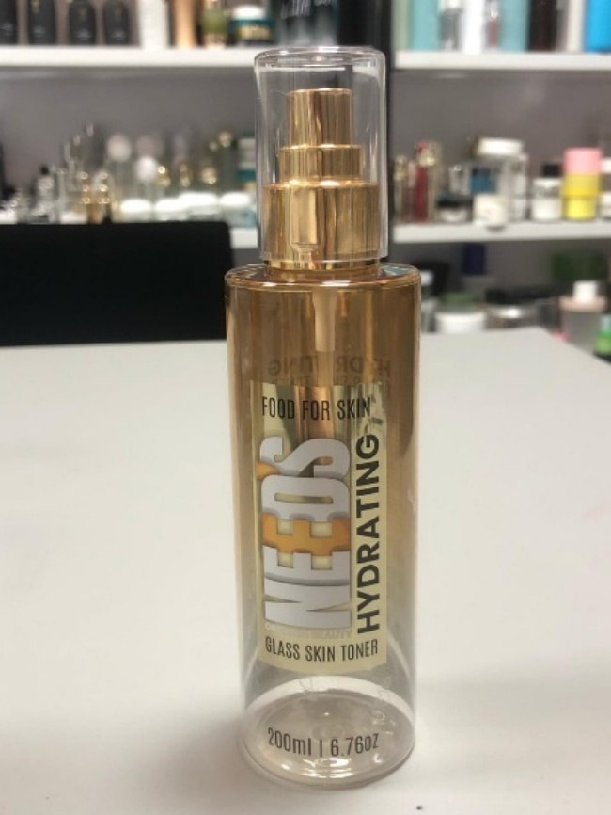
Need's Hydrating Glass Skin Toner 200ml
Price 4490 | Discount Price 3990
👉🏻Deep Hydration & Skin Barrier Support
( Infused with Sodium Hyaluronate,Hydrolyzed Hyaluronic Acid,and Sodium Acetylated Hyaluronate for multi-level hydration,improving skin elasticity and moisture retention.)
👉🏻Powerful Soothing Agents
(Calm irritation and reduce redness,leaving the skin refreshed and balanced)
👉🏻Antioxidant-Rich Formula
(Protect against environmental stressors and promote a radiant complexion)
👉🏻Nutrient-Boosted Glow
(Brighten,smooth,and rejuvenate dull,tired skin)
👉🏻Gentle for All Skin Types
( Lightweight and alcohol-free,this toner delivers hydration and nourishment without clogging pores or causing sensitivity)

KEY INGREDIENTS
⭐Hyaluronic Acid ⭐Sodium Hyaluronate
⭐Niacinamide(Vitamin B3) ⭐Glutathione
⭐Centella Asiatica Extract ⭐Camellia Sinensis (Green Tea)
⭐Helianthus Annuus (Sunflower) Seed Oil Unsaponifiables
⭐Glaycolic Acid ⭐Allantion

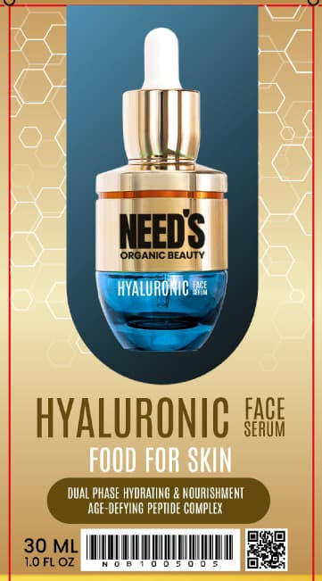
Need's Hyaluronic Acid Face Serum 30ml
Price 5290 | Discount Price 4790
👉🏻Dual-Phase Hydration & Nourishment
z( The Unique two-phase formula powerful Blueberry Extract and Aloe vera Leaf Water,offering deep hydration and soothing properties while replenishing the skin's moisture balance.)
👉🏻Age-Defying Peptide Complex (Anti-Ageing)
Combiness poweful peptides to visibly reduce fine lines and wrinkles,promoting smoother,firmer,and more youthful-looking skin.
👉🏻Skin Barrier Strengthening
(Repairs and reinforces the skin's natural barrier,boosting elasticity while shielding against environmental stressors)
👉🏻Radiance-Boosting & Soothing Care
(Gently exfoliates,brightens,and calms the skin,helping to reduce redness and enhance your complexion natural glow)
👉🏻Advanced Antioxidant Defense
(Packed with antioxidants to protect the skin from free radical damage and support its natural healing process,promoting healthier skin)

KEY INGREDIENTS
⭐Hyaluronic Acid ⭐Mandelic Acid
⭐Copper Tripeptide ⭐Centella Asiatica
⭐Vitamin E ⭐Hexapeptide 1-3-9
⭐ Allantion ⭐Jojoba seed Oil
⭐Vaccinium Angustifolium (Blueberry) Fruit
⭐Acetyl Hexapeptide-8 ⭐Palmitoyl

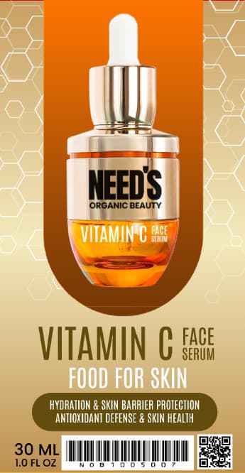
Need's Vitamin C Face Serum 30ml
Price 4990 | Discount Price 4490
👉🏻Powerful Vitamin C Complex
(Formulated with 3-O-Ethyl Ascorbic Asid,a stable form of Vitamin C,this serum brightens the complexion,reducing the appearance of dark spots and hyperpigmentation for a more even skin tone.)
👉🏻Multi-Vitamin Blend for Radiant Skin
(Nourishes and revitalizes the skin,leaving it glowing and healthy.)
👉🏻Hydration & Skin Barrier Protection
(Help to Restore moisture,improve the skin's hydration levels and reinforce the natural skin barrier for smoother,more resilient skin)
👉🏻Soothing and Calming
(Help calm irritated skin,reduce redness and promote a balanced,calm complexion)

KEY INGREDIENTS
⭐3-O-Ethyl Ascotbic Acid (Stable Vitamin C)
⭐Phytonadione (Vitamin K) ⭐Niacinamide(Vitamin B3)
⭐Tocopherol (Vitamin B5) ⭐Cholecalciferol (Vitamin D3)
⭐Sodium Hyaluronate ⭐Butylene Glycol
⭐Trehalose ⭐Zinc PCA
⭐Rosa Rugosa Flower Oil

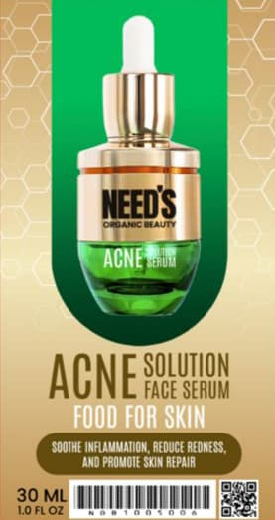
Need's Acne Solution Face Serum 30ml
Price 4990 | Discount Price 4490
👉🏻Advanced Acne Control
( Formulated with Salicylic Acid and Willow Bark Extract,this serum penetrates deep into pores to clear breakouts,reduce excess oil,and prevent future blemishes.)
👉🏻Exfoliation Without Irritation
(Gentle acids smooth skin texture by encouraging cell turnover while minimizing redness and sensitivity.)
👉🏻Calming & Soothing Power
(Soothe inflammation,reduce redness,and promote skin repair.)
👉🏻Oil-Balancing & Hydration
(Combines Zinc PCA and Hyaluronic Acid to regulate sebum production while deeply hydrating for a balanced,healthy complexion)
👉🏻Antioxidant Protection
(Shield skin from environmental stressors and promote a more radiant,even-toned appearance)

KEY INGREDIENTS
⭐Salicylic Acid ⭐Lactobionic Acid
⭐Sodium Lactate ⭐Pentylene Glycol
⭐Salix Alba (Willow) Bark Extract ⭐Camellia Sinensis Leaf Extract
⭐Centella Asiatic Extract ⭐Madecassoside
⭐Hyaluronic Acid

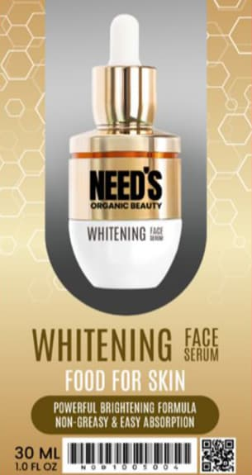
Need's Whitening Face Serum 30ml
Price 4990 | Discount Price 4490
👉🏻Power Brightening Formula
( Features Alpha-Arbutin and 3-O-Ethyl Ascorbic Acid,which target dark spots and discoloration for a visibly brighter,more even complexion.)
👉🏻Cooling & Refreshing Sensation
(Lightweight,fast-absorbing texture delivers an instant cooling effect,perfect for revitalizing men's skin.)
👉🏻Hydrating & Soothing Benefits
(Deeply hydrate,calm irritation,and strengthen the skin barrier)
👉🏻Anti-Fatigue Complex
(Combat signs of tiredness,reduce fine lines,and restore energy to your skin)
👉🏻Non-Greasy & Easy Absorption
(Specially designed for men's thicker skin,the serum leaves no residue ensuring a fresh,matte finish for all-day confidence.)

KEY INGREDIENTS
⭐Bifida Ferment Lysate ⭐Acetyl Hexapeptide-8
⭐1,2-Hexanediol ⭐Alpha-Arbutin
⭐Sodium Hyaluronate ⭐3-O-Ethyl Ascorbic Acid
⭐Glutathione ⭐Inositol (Vitamin B Complex)
⭐Rosa Rugosa Flower Oil.

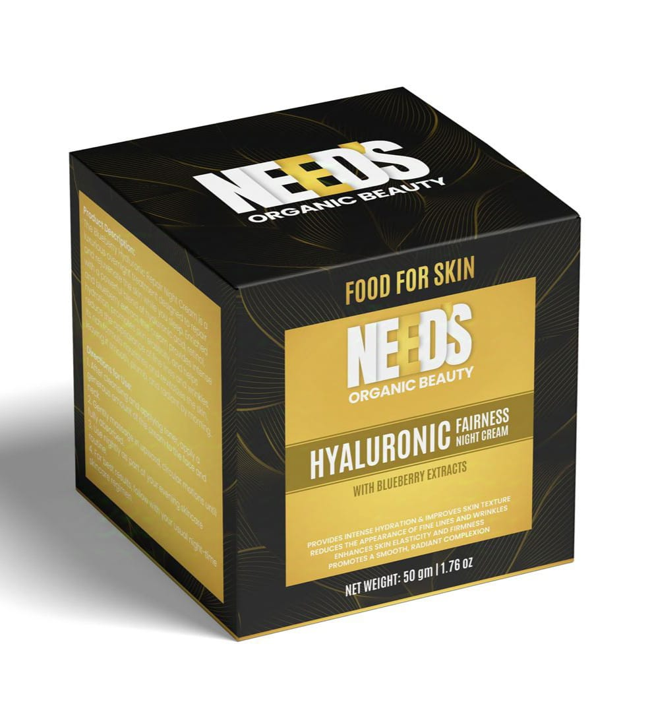
Need's Hyaluronic Fairness Night Cream *50ml
Price 7290 | Discount Price 6790
👉🏻Age-Defying Transformation
( Reducing the appearance of fine lines and wrinkles while promoting a smoother,more even skin tone.Wake up to younger-looking skin every day.)
👉🏻Firm,Youthful Glow
(Boost collagen,frim the skin,and restore elasticity.Enjoy visibly lifted,smoother,and more youthful skin every morning)
👉🏻Nourishing & Soothing
(Nourishes and calms your skin,leaving it soft,supple,and perfectly balanced.)
👉🏻Powerful Antioxidant Protection
(Potent antioxidants that protect your skin from daily environmental damage,helping to preserve a youthful,radiant complexion)
👉Wake Up to Radiant Skin
(Provides intense moisture,leaving your skin plump,refreshed,and glowing by morning.)

KEY INGREDIENTS
⭐Sodium Hyaluronate ⭐Acetyl Hexapeptide-8
⭐Retinol ⭐1-2-Hexanediol
⭐Lecithin ⭐Allantoin
⭐Glutathione ⭐Vaccinium Angustifolium (Blueberry) Fruit Extract
⭐Caprylic/Capric Triglyceride ⭐Alumina Magnesium
⭐Simmondsia( Jojoba Seed

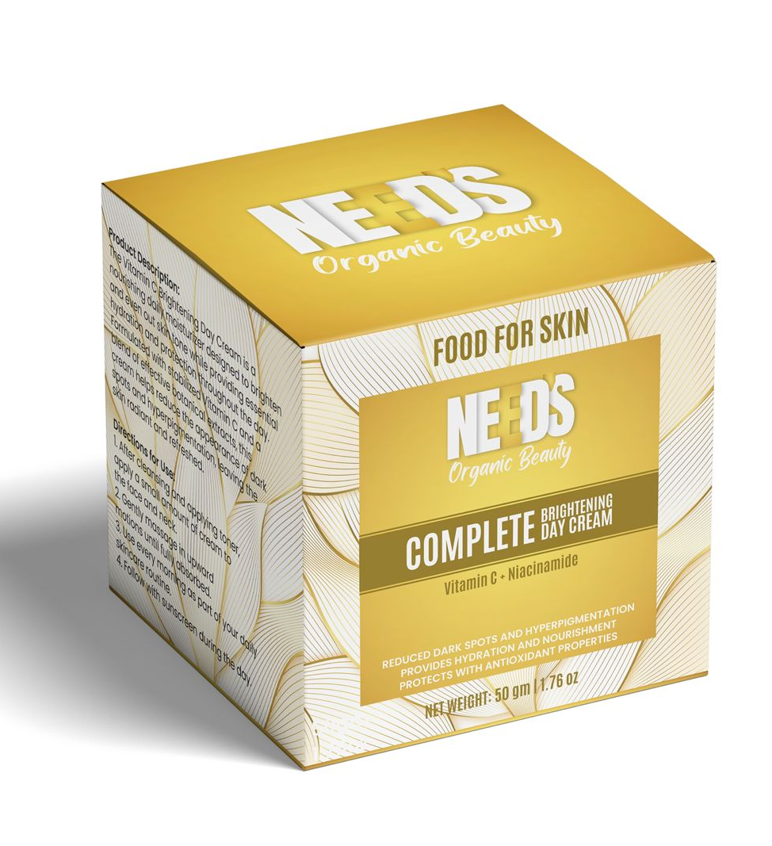
Need's Vitamin C Brightening Day Cream * 50ml
Price 6790 | Discount Price 6490
👉🏻Advanced Brightening & Face Glowing
(Enriched with 3-O-Ethyl Ascorbic Asid,a stable form of Vitamin C, and Niacinamide,this cream visibly reduces dark spots and evens skin tone for a radiant,luminous complexion.)
👉🏻Long-Lasting Hydration & Skin Barrier Support
(Deeply hydrates and nourishes the skin,reinforcing the natural barrier for smoother,softer texture.)
👉🏻Antioxidant & Environmental Defense
(Protects against free redical damage and soothes the skin,promoting a healthy glow)
👉🏻Skin-Soothing and Restorative Formula
(Calms irritated skin,reduces redness,and restores balance for a comfortable,refreshed feel all day long.)
👉🏻Perfect Daily Base
(Lightweight and non-greasy,this cream absorbs quickly,leaving the skin soft,Smooth,and perfectly prepped for makeup application or daily wear.

KEY INGREDIENTS
⭐3-O-Ethyl Ascotbic Acid ⭐Butylene Glycol
⭐Niacinamide ⭐Glutathione
⭐Beta-Carotene ⭐Tocopherol (Vitamin E)
⭐Sodium Hyaluronate ⭐Butylene Glycol
⭐Sophora Angustifolia Root Extract ⭐Salvia Miltiorrhiza Root Extract
⭐Piper Methysticum Root Extract ⭐1-2-Haxanediol
⭐Panthenol (Vitamin B5)

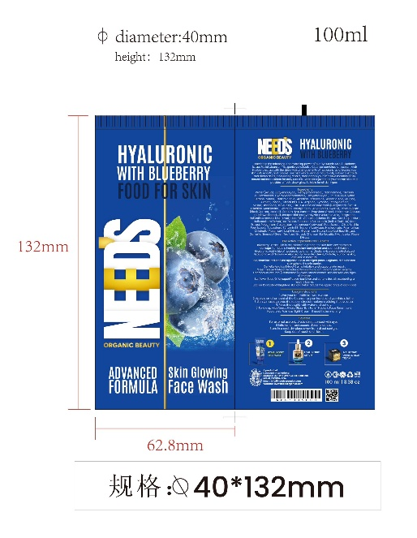
Price 1990
Discount Price 1490

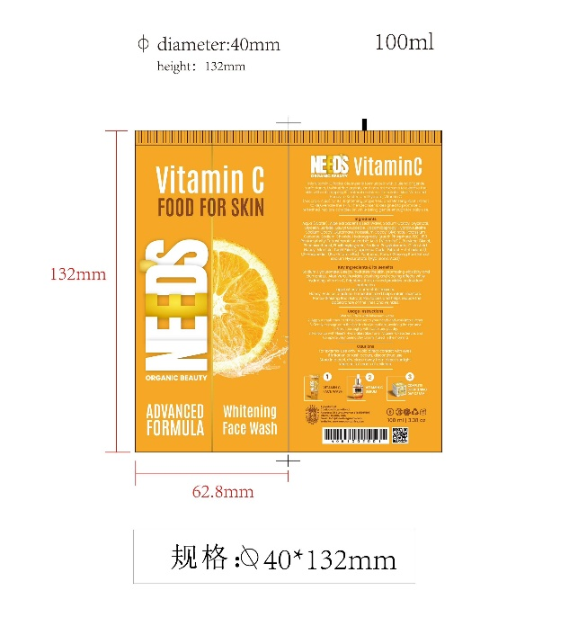

Price 1990
Discount Price 1490

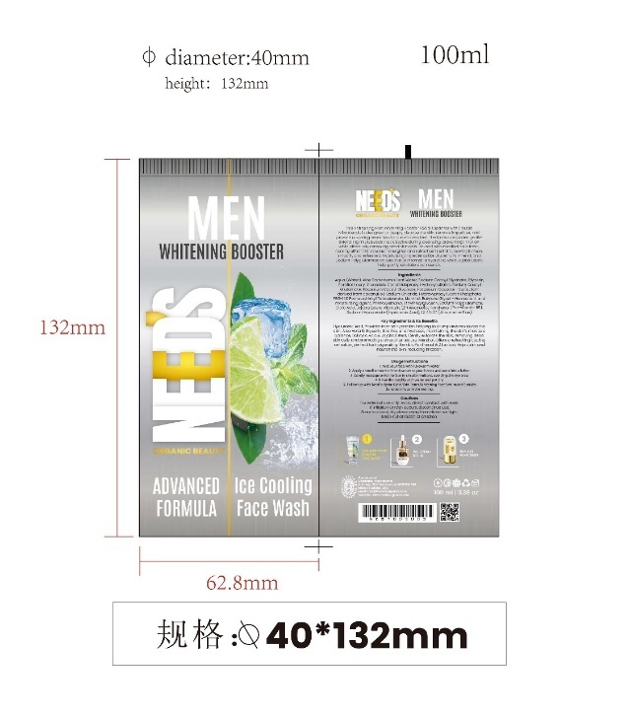

Price 1990
Discount Price 1490

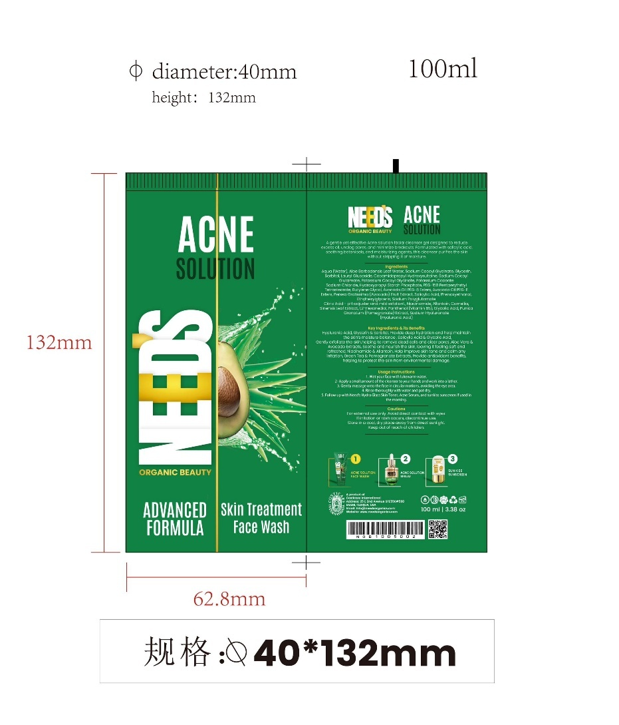

Price 1990
Discount Price 1490

……………………………………………………………………

All Products in this line..
Google Drive link: Front Single Imges - Google Drive
Email: Costicareinternational@gmail.com
Password: P@ssword1122

Website Design Idea (Similar like this)
https://www.kikocosmetics.com/en-us/

Website Hero Image Idea.
https://www.instagram.com/reel/DRUYFarjBH6/?igsh=MWltMXppZnZoYjVsNQ==

- Home Page → Trending/featured products
- Product List → With filters/sort/pagination
- Product Detail → Gallery, add to cart, reviews
- Cart Page → Manage items
- Checkout → Enter address, place order
- User Dashboard → Profile, orders, reviews
- Admin Panel → Add/edit products, manage orders

Customer Side:
- User registration & login (email/password)
- Product listing & filtering (category, brand, price, rating)
- Product detail page with image gallery
- Add to cart / wishlist
- Checkout with address management
- Order history
- Ratings & reviews
- Responsive UI/UX

Admin Side:
- Login & role-based access
- Product CRUD (Add, Update, Delete)
- Category & brand management
- View all orders
- Order status updates (Pending, Shipped, Delivered)
- Dashboard with key metrics

